**Credit for Life Fair is a Big Hit with Masco Juniors**

On April 5th, 176 Masco juniors joined approximately 700 students from area high schools in the Credit for Life Fair. This was the first year the event, sponsored by the Institution for Savings, was held in Masconomet’s Field House.

The Fair is a simulation of the financial decision-making that a 25-year old professional will face. This annual event also includes surrounding schools like Pentucket Regional; Newburyport, Triton Regional, Ipswich, Rockport, Gloucester and Beverly.

With the addition of new schools came many more students in attendance.

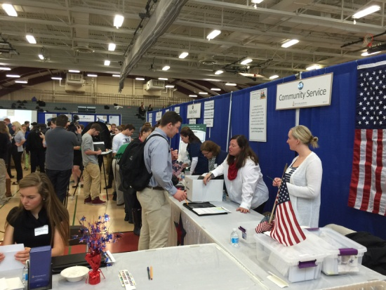

“This added approximately 350 students - almost 900 this year, which forced us to move the event from Triton to Masconomet which offered more space,” said Vice President of the Institution for Savings, Mary Anne Clancy.

The Field House was divided into 15 stations that the students must visit to make purchases and learn how to balance their budgets. These booths include everything from Housing to Transportation to Clothing. These booths give students ideas about the actual cost depending on different factors, such as their career choice and credit score. Students all chose their careers weeks before the event and the Institution for Savings created budget sheets and a random credit score affecting the interest rates that would be offered.

Some of the booths became more popular than others. “The booth entitled “‘Fun, Fun, Fun!’ was very popular because students got to buy cruises and sports tickets and ‘fun’ stuff—IF they could afford it. Reality Check is also a good booth because students get to spin the wheel or barrel and take a chance on winning things…or paying more from their budget,” said Clancy.

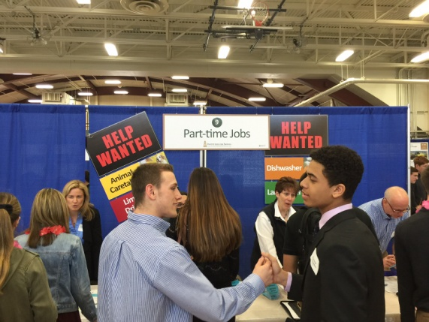

Masco began its participation in the Credit for Life Fair three years ago as a way to give more students exposure to financial literacy. “With so many students graduating high school without taking a financial literacy course or understanding how credit works, this day is focused on giving students the opportunity to see the realities of managing one’s own money and spending it wisely within a budget. They also gain further understanding about how one’s credit score will affect their ability to borrow money to make large purchases and what they will be able to afford by living within their means,” said Ben Hodges, Director of the Business and Computer Science Department.

The Credit for Life Fair is an eye-opening opportunity for students to learn about the real expenses of living. “The students’ salaries are based on the average starting salaries for their chosen professions. Some students certainly start out with higher salaries, such as those who choose to be doctors, lawyers or investment bankers. No matter what your starting salary, you still need to buy the basics like housing, transportation and groceries,” said Clancy. Some of these costs can be lowered with a roommate.

Junior Sam Scherbak said, “Having a partner was very helpful because we could combine our knowledge and work together to make the most rational decisions possible.”

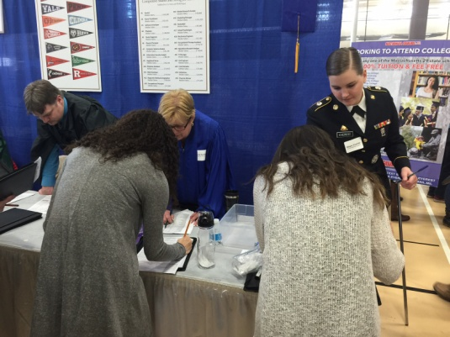Students learned about these decisions and the responsibility that came with making them. “I learned that the working world is exciting, but it comes with a lot of responsibilities. Something could happen suddenly, but at the fair we learned how to plan in advance for those possibilities,” said junior Allie Adam. “We hope to continue to grow and expand this program every year. We always have requests from other communities and schools who would love to be included in this event. Eventually we would love it to be a mandated program for every high school junior,” said Clancy. “One of the suggestions we may adopt is to have an Animal Rescue Booth where students can adopt a pet if they so choose.”

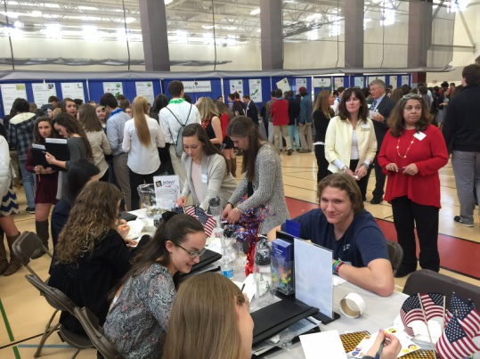Many hope to see this program continue to grow and see how it affects the lives of someone just coming out of college. Every year there is a follow-up meeting to assess changes and improvements that can be made to continue creating an authentic and worthwhile learning experience for students.

*Note: All graduating seniors are required to take a 1.5 hour course titled “Credit Counts”, with curriculum provided by the Institution for Savings.*

*This School Committee submission was prepared by Candra Pepper, a junior in the Masconomet High School Media Communications/Journalism course. She has written over 24 articles for the Chieftain Chronicle, Masco’s school newspaper that runs in the Tri Town Transcript, and for the sports section of the Tri-Town Transcript. Masconomet was proud to host this regional learning experience for the first time in 2016.*

